Assignment –Classification Algorithm

1. Identify your problem statement:

Stage 1: Machine Learning(inputs are present in numerical)

Stage 2: Supervised Learning(input and outputs are clear)

Stage 3: Supervised -Classification(output is categorical value)

2. Tell the basic info about your dataset:

There are 399 rows × 25 columns in the given dataset.

Input columns/dependent: 'age', 'al', 'su', 'bgr', 'sc', 'pot', 'hrmo', 'pcv',

'wc', 'rc', 'sg_b', 'sg_c', 'sg_d', 'sg_e', 'rbc_normal', 'pc_normal',

'pcc_present', 'ba_present', 'dm_yes'.

Output column/independent: ‘classification_yes’.

3. Mention the pre-processing method:

From the given dataset some columns are string format,so converting to nominal data(one hot encoding) is used in pre-processing method.

4. Develop a good model with Evaluation Matrix values:

* **LOGISTIC REGRESSION: (Evaluation Matrix value) = 0.99**

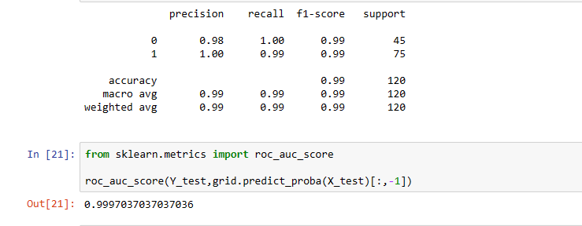

* **SVM**

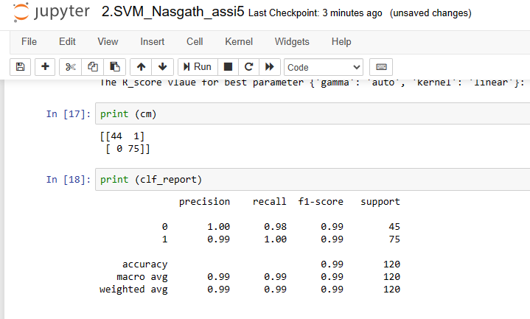

* **DECISION TREE**

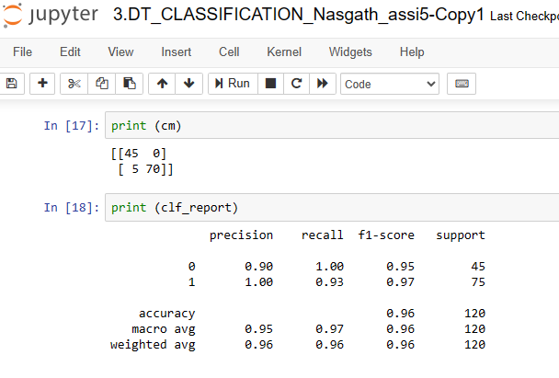

* **RANDOM FOREST:**

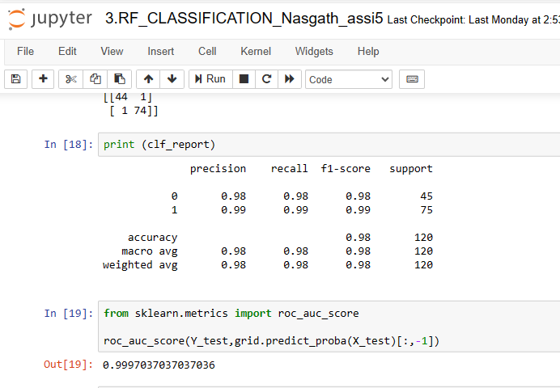

* **KNN**

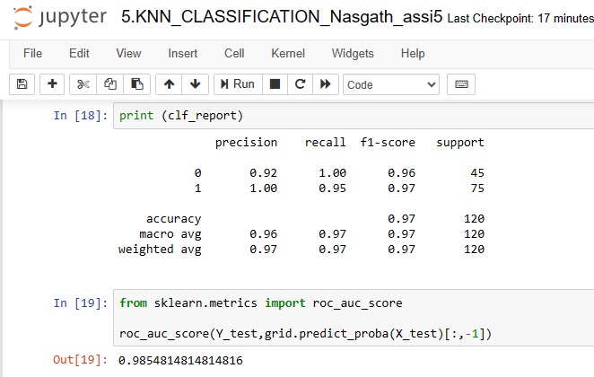

* **Navie Bayes: Gaussian NB**

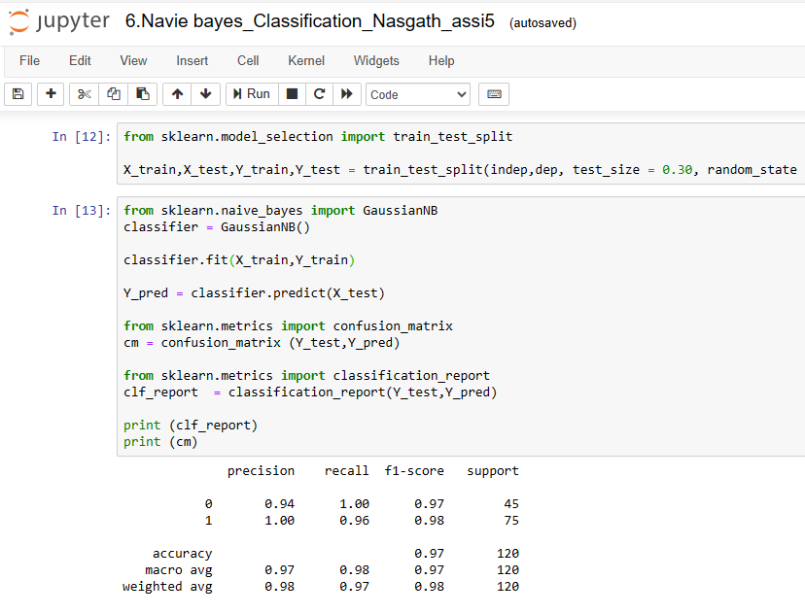

* **Multinomial NB:**

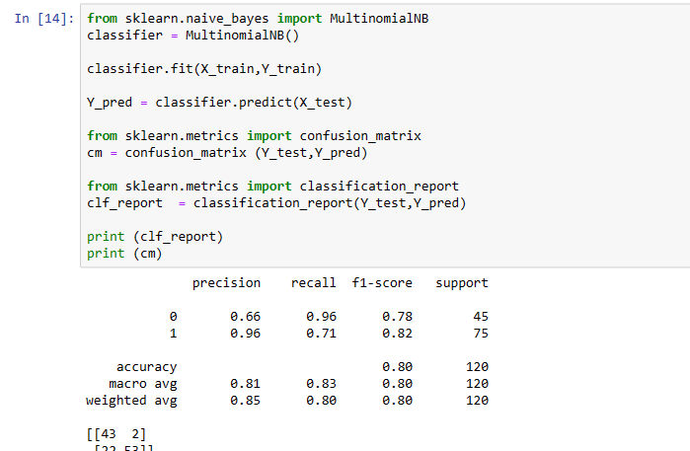

* **BernoulliNB:**

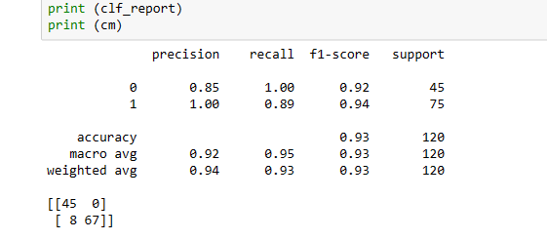

* **ComplementNB:**

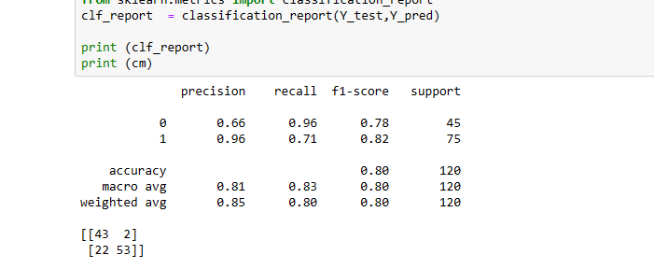

6. Mention the final model and justiy:

The final model I have chosen is Logistic regression and SUPPORT VECTOR MACHINE, since the accuracy value **0.99 which is nearly to 1**.